# 1.

## Goal

Implement a secure Login for Advisor (use of JFrame and file).

## Test name

Secure login

## The initial data of test case

Username: John

Password: asd123

User role: Advisor

## Expected output of the test case

No other person other than the one with the correct credentials will be able to log into the Advisor account of John. In the case wrong credentials are entered, the system will display a message informing the person trying to login. Otherwise, the calculator (the first tab) will be displayed after successful login.

## The produced output

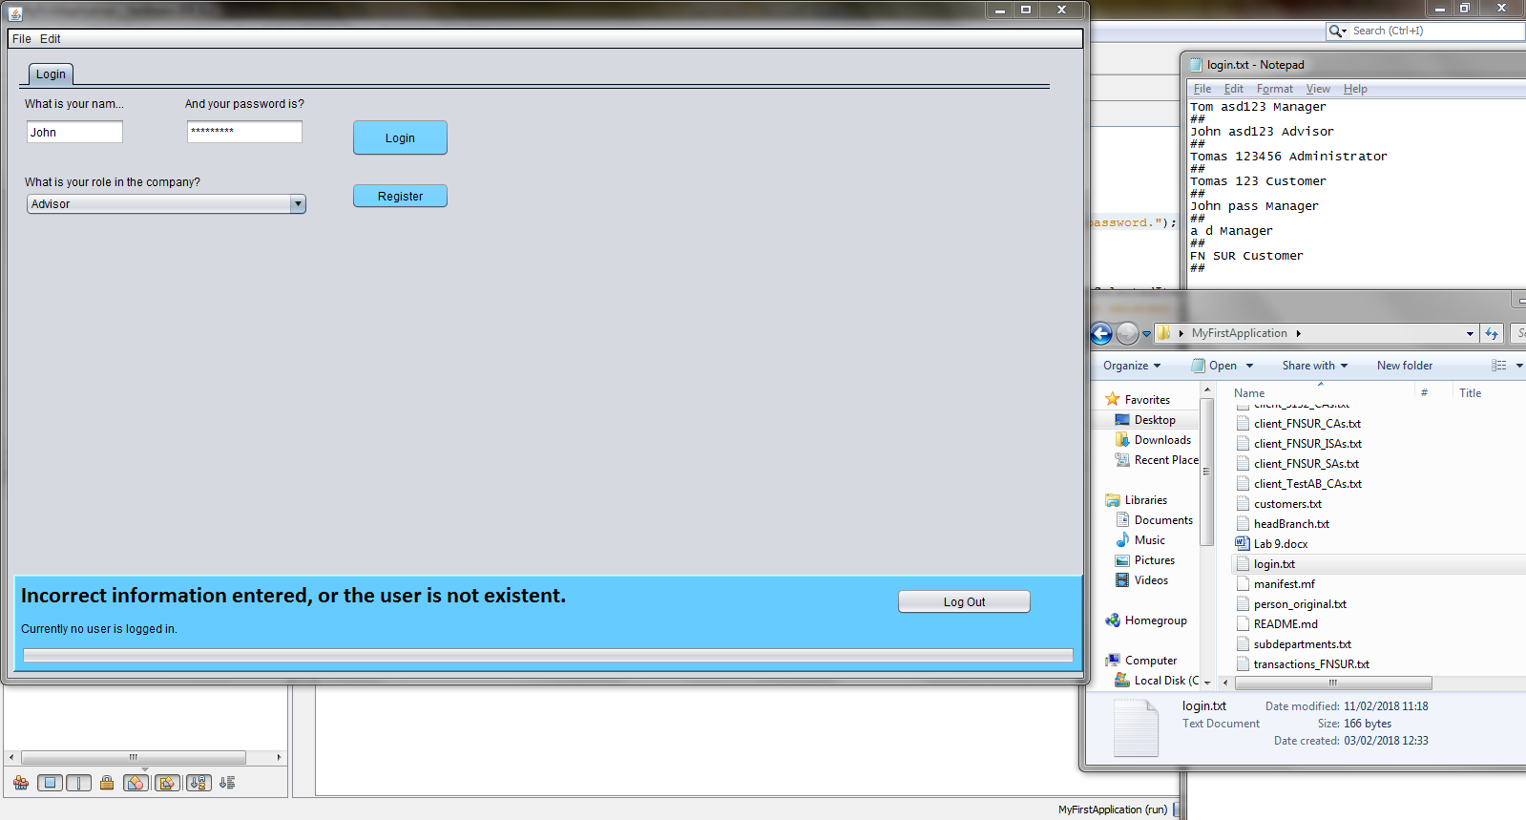

Figure If the password entered is not correct

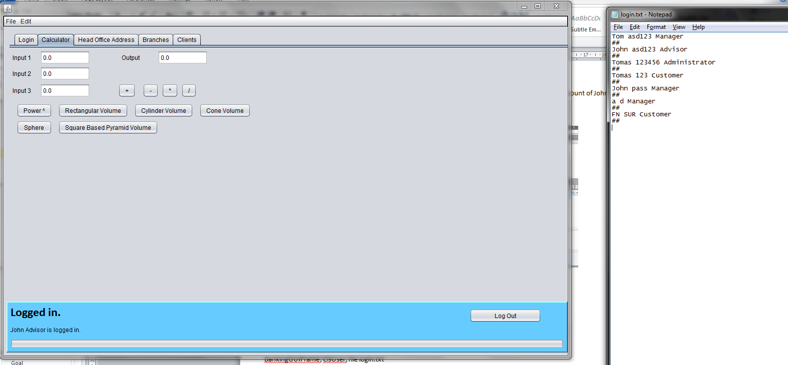

Figure If the password entered is correct

## The outcome of the test

The test is passed.

## Objects used

BankingGUIFrame; theUser in ClsUser; file login.txt

# 2.

## Goal

Change of Password (use of JFrame and file)

## Test name

Password change.

## The initial data of test case

Username: John

Password: asd123

User role: Advisor

## Expected output of the test case

The password which John uses will be changed from “asd123” to anything he would like.

## The produced output

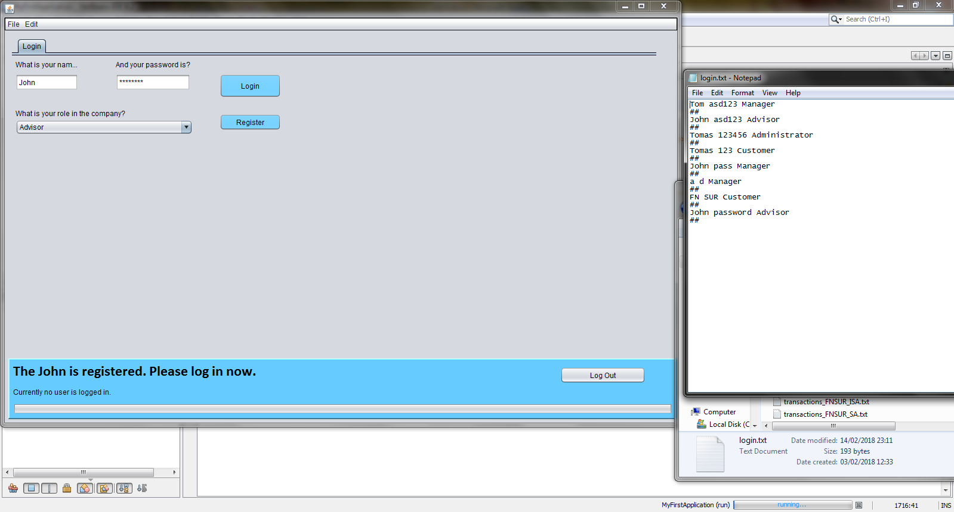

Figure New password is stored in the file with the username John and his role Advisor

## The outcome of the test

Partial pass - the old password has to be removed from the file.

## Objects used

BankingGUIFrame; theUser in ClsUser; file login.txt

# 3.

## Goal

Display Address of Bank (using JFrame (represents Bank) and BankAddress object type of IAddress (declared in JFrame).

## Test name

Display of Bank’s address.

## The initial data of test case

**Login data for Administrator:**

Username: Tomas

Password: 123456

Role: Administrator

## Expected output of the test case

The software should display the full address of the bank branch in a text area.

## The produced output

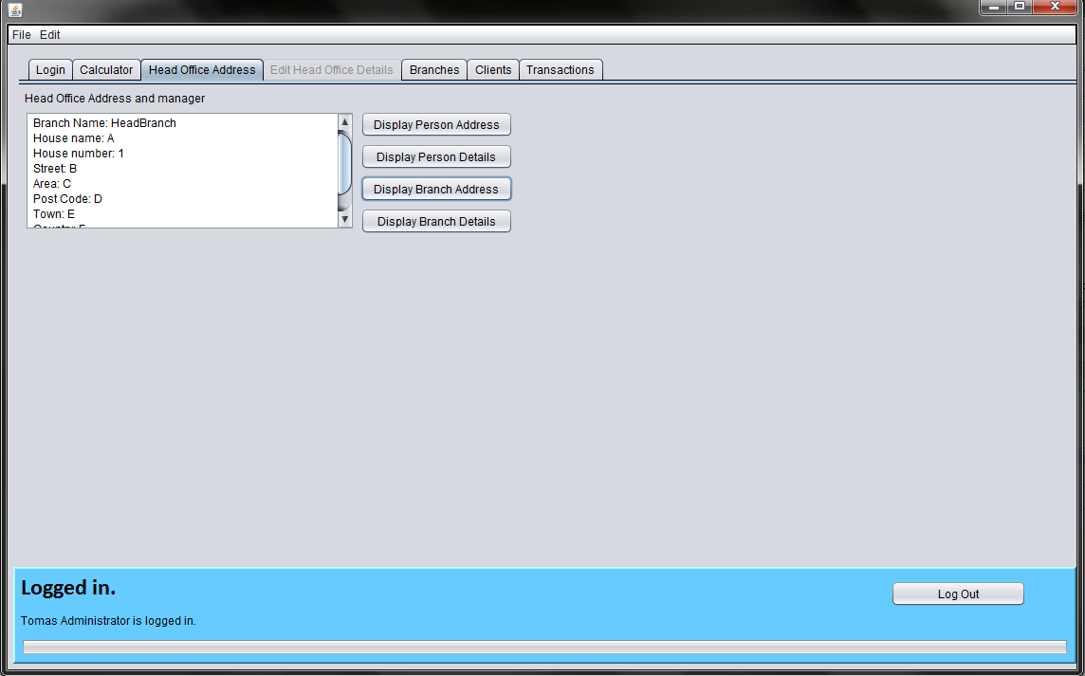

Figure Address of the Head Office Branch of the Bank is displayed in the text area

## The outcome of the test

Passed - the full address is displayed in the text area.   
Further development possible: upsize the textual area so a user does not have to scroll to see the full address.

## Objects used

BankingGUIFrame; theHeadOfficeBranch in ClsBranch; theAddress in ClsIAddress; the address object is instantiated in the BankingGUIFrame on the line 42.

# 4.

## Goal

Display Branch Address (using JFrame (for displaying the data), Branch object declared in JFrame and BranchAddress object type of IAddress, declared in Branch class.

## Test name

## The initial data of test case

**Login data for Administrator:**

Username: Tomas

Password: 123456

Role: Administrator

## Expected output of the test case

Full address of each of bank branches of a bank is displayed in the text area.

## The produced output

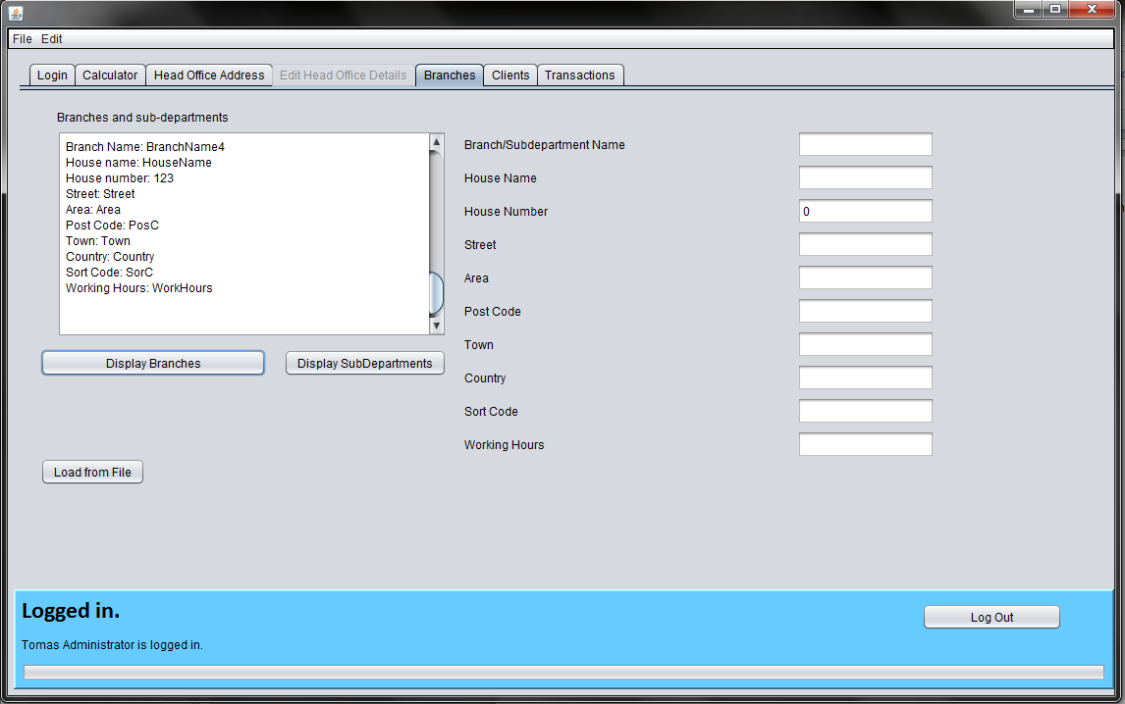

Figure View of branches for the user role of Administrator

## The outcome of the test

Passed.

## Objects used

BankGUIFrame, bankBranches in ClsBranchList, Branch in ClsBranch, theAddress in ClsIAddress

# 5.

## Goal

Display Customer List (using object type of CustomerList declared in JFrame, customers objects declared as array in CustomerList class) The use case should display the following information: name, firstname and the home address.

## Test name

Displaying of customers’ details and address.

## The initial data of test case

**Login data for Manager:**

Username: Tom

Password: asd123

Role: Manager

## Expected output of the test case

A user will see all clients/customers in a text area with their details and corresponding home addresses.

## The produced output

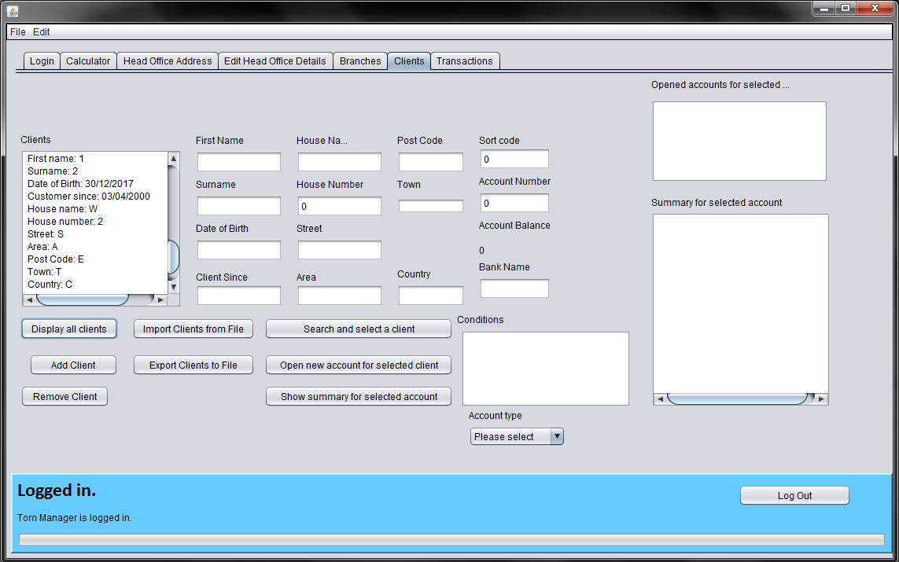

Figure Test client with name "1" and surname "2" is displayed

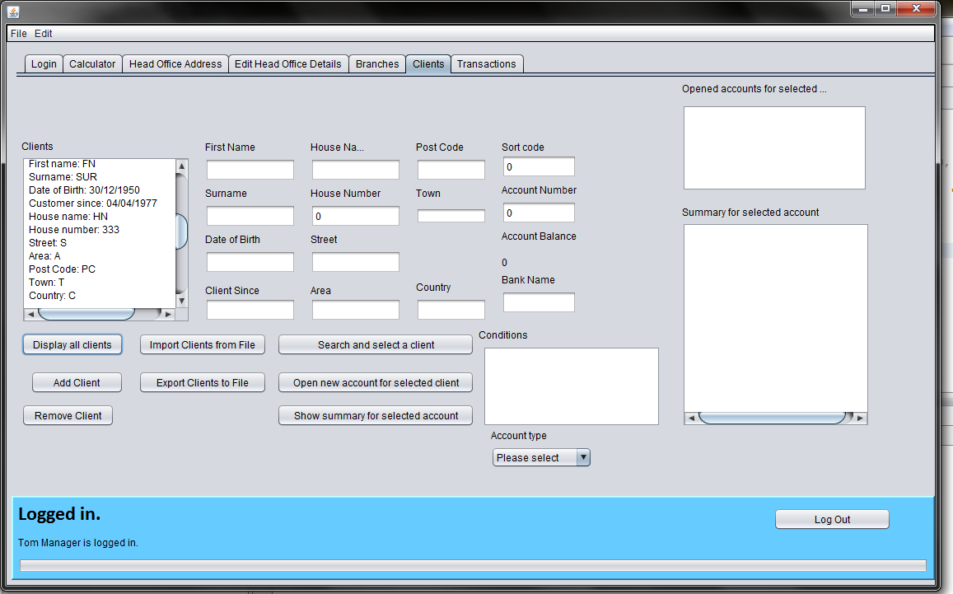

Figure Above the test client "1", there is another test client "FN SUR" displayed from the array list of clients

## The outcome of the test

Passed.

## Objects used

BankGUIFrame, bankClients in ClsCustomerList, Client in ClsCustomer, homeAddress in IClsAddress

# 6.

## Goal

Find and display customer (using JFrame, CustomerList object, Customers array declared in CustomerList object)

## Test name

Customer search

## The initial data of test case

**Login data for Manager:**

Username: Tom

Password: asd123

Role: Manager

**Customer to be searched for:**

Customer’s personal details:

First name: FN

Surname: SUR

Date of birth: 30/12/1950

Customer since: 04/04/1977

Customer’s home address:

House name: HN

House number: 333

Street: S

Area: A

Postcode: PC

Town: T

Country: C

## Expected output of the test case

After entering all client details (first name, surname, DOB, Customer since) and the full client’s address, it is possible to search for the customer. The client is usually asked of these details and therefore all of the details are required to be entered before permitting the search for the customer. Once the search is performed, the system should display all the details and the address in the text field and select this customer.

If any details entered have incorrect format, are of value different from the one stored in the customer’s file (which is loaded to the array of the customers), then the system will notify the user.

## The produced output

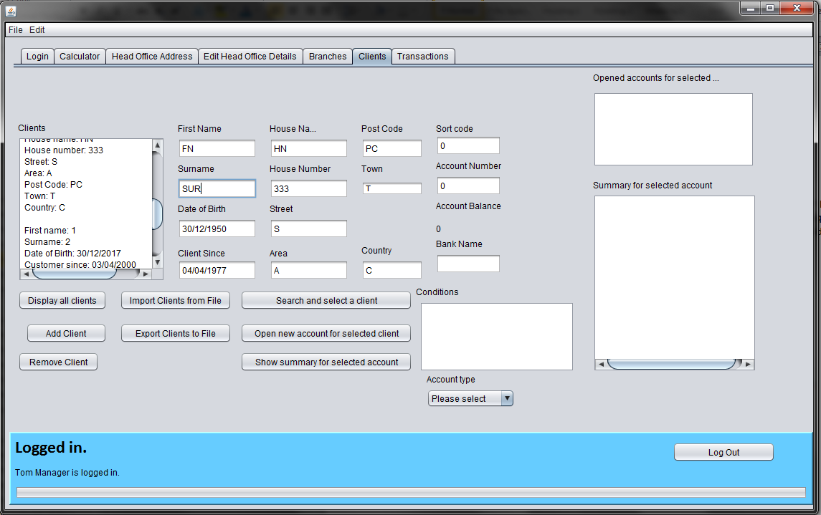

Figure After filling in all the personal and address details of a client, before searching for the client

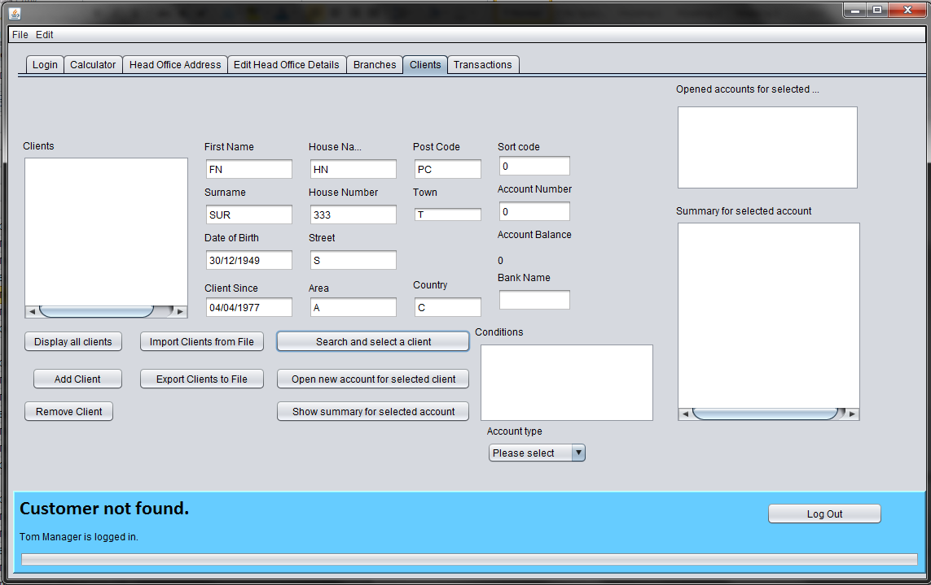

Figure If there is any entered data incorrect or different from the value associated with the customer, such as DOB in this case, the system shows "Customer not found"

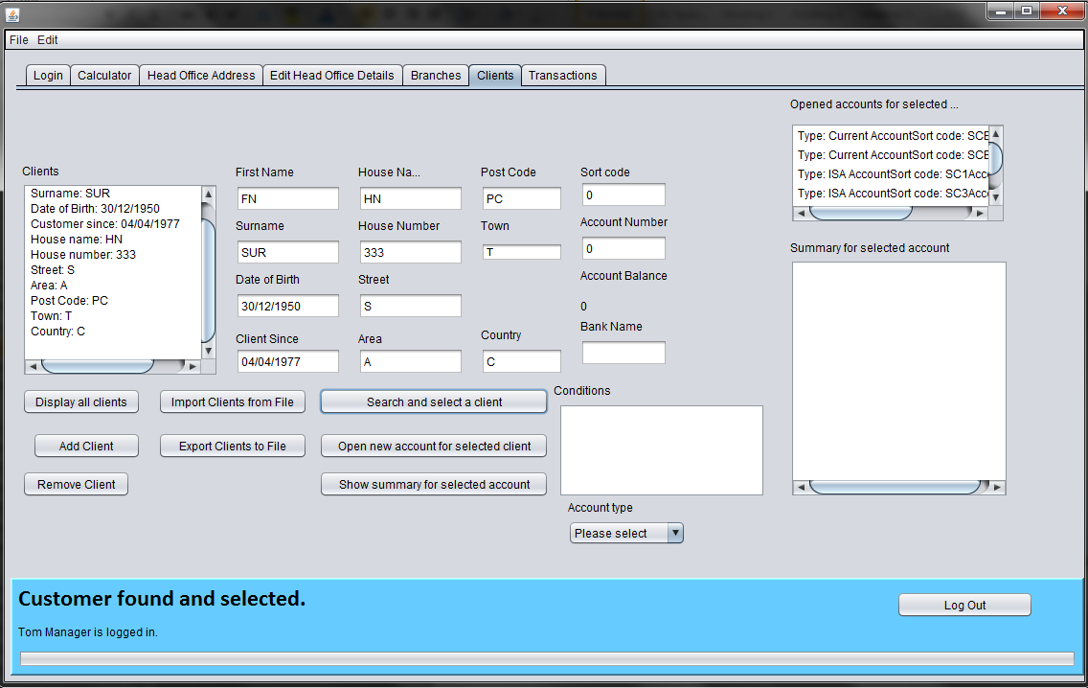

Figure If all details are correct, the customer's details are shown and the customer is selected. All opened accounts associated with the customer are loaded and displayed in the list on the right hand side. Searching for a different customer, loads the accounts of the customer searched for.

## The outcome of the test

Pass.

## Objects used

BankGUIFrame, bankClients in ClsCustomerList, theCustomer in ClsCustomer, homeAddress in ClsIAddress

# 7.

## Goal

Customer login (the customer is allowed to view only information related to the customer. The customer is not allowed to view information about any other customers in the bank ) – (using JFrame, CustomerList object, find function in CustomerList class and display information for specific Customer only)

## Test name

Customer’s login

## The initial data of test case

**Login data for the Customer:**

Username: Tomas

Password: 123

Role: Customer

**The only data which the customer should see after logging in:**

Customer’s personal details:

First name: FN

Surname: SUR

Date of birth: 30/12/1950

Customer since: 04/04/1977

Customer’s home address:

House name: HN

House number: 333

Street: S

Area: A

Postcode: PC

Town: T

Country: C

## Expected output of the test case

After logging in, the customer will not be able to see any other data rather than their own and won’t be able to change, import or export any other data than their own.

## The produced output

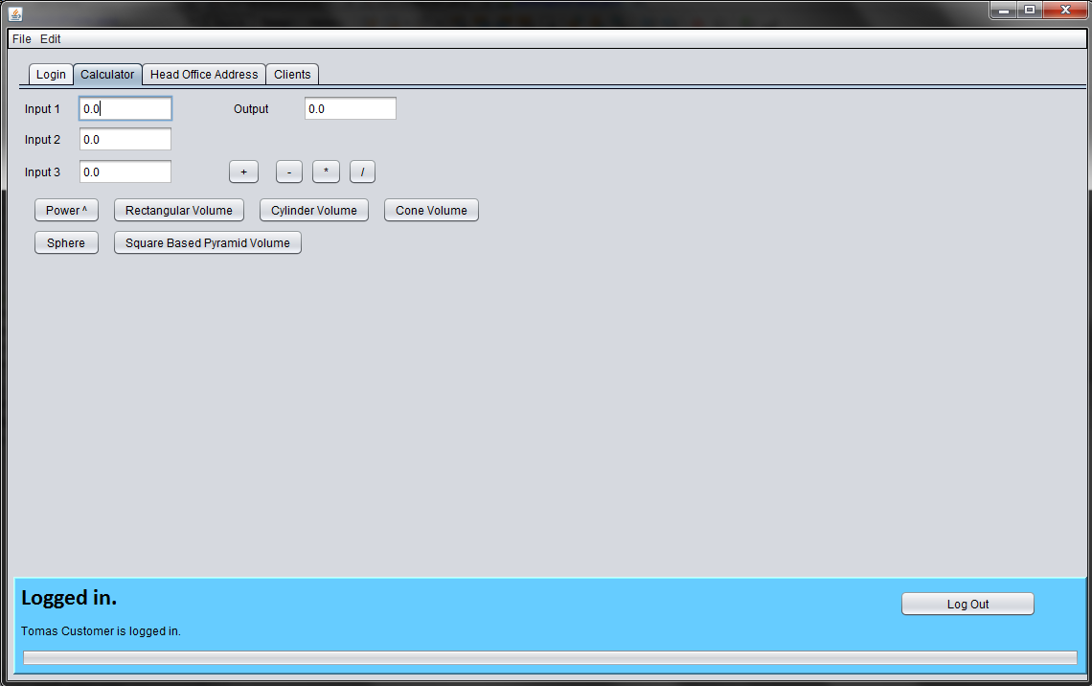

Figure After logging in, the customer is presented with the calculator tab and can view the head office address and details (i.e. working hours)

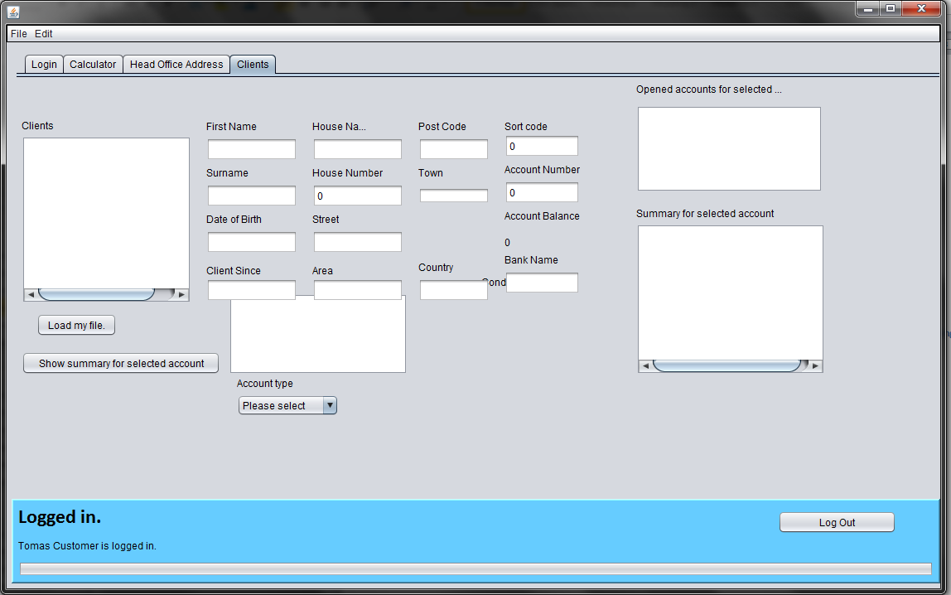

Figure After opening the Clients tab, the client is presented with a changed interface and limited options and has to fill in all his details before displaying accounts associated to his person.

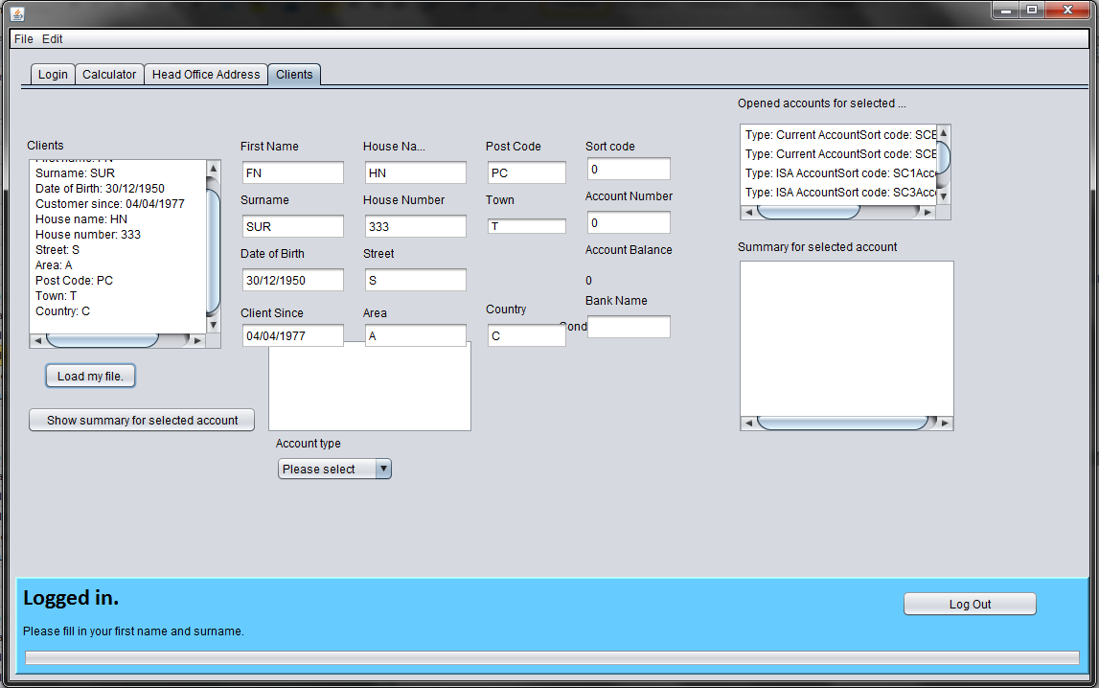

Figure Data for the customer FN SUR are displayed and accounts are loaded to the system.

## The outcome of the test

Passed.

## Objects used

BankGUIFrame, theUser of ClsUser, bankClients of ClsCustomerList, theCustomer of ClsCustomer, homeAddress of ClsIAddress

# 8.

## Goal

Display Account Information (using JFrame, CustomerList object, Customers array declared in CustomerList object, Account object in Customer class)

## Test name

The display of account information for a particular client’s account.

## The initial data of test case

## Expected output of the test case

## The produced output

## The outcome of the test

## Objects used

# 9.

## Goal

## Test name

## The initial data of test case

## Expected output of the test case

## The produced output

## The outcome of the test

## Objects used

# 10.

## Goal

## Test name

## The initial data of test case

## Expected output of the test case

## The produced output

## The outcome of the test

## Objects used

# 11.

## Goal

## Test name

## The initial data of test case

## Expected output of the test case

## The produced output

## The outcome of the test

## Objects used

# 12.

## Goal

## Test name

## The initial data of test case

## Expected output of the test case

## The produced output

## The outcome of the test

## Objects used